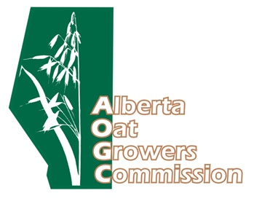
Annual General Meeting
Thursday, April 8 – 2021
1:00 PM
Due to COVID-19 the AGM will be held virtually via Zoom.

1:00 pm Welcome from the AOGC: Chair - Brad Boettger, Tofield, AB
1:05 pm AOGC Business Meeting* including director election/acclamation, financial reporting & project updates.
1:25 pm Oat Market Outlook
Chris Newbergher, Grain Marketing Specialist, Stony Plain Seed Cleaning
2:00 pm Adjourn

- Please RSVP to info@poga.ca, and check poga.ca for the meeting documents.

